Bài 1 :
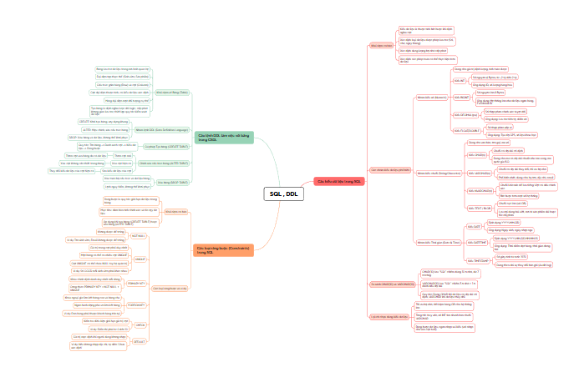
Bài 2 – 3 – 4 – 5 – 6 – 7 :
CREATE DATABASE Session02;
USE Session02;

-- BAI 2
CREATE TABLE Class (
ClassId VARCHAR(20) NOT NULL PRIMARY KEY,
ClassName VARCHAR(20) NOT NULL,
SchoolYear INT
);
CREATE TABLE Student (
StudentID VARCHAR(20) NOT NULL PRIMARY KEY,
FullName VARCHAR(200) NOT NULL,
BirthDate DATE,
ClassId VARCHAR(20),
CONSTRAINT FK_Student_Class
FOREIGN KEY (ClassId) REFERENCES Class(ClassId)
);

-- BAI 3
USE Session02;
CREATE TABLE Student_B3 (
StudentId VARCHAR(20) NOT NULL PRIMARY KEY,
FullName VARCHAR(100) NOT NULL
);
CREATE TABLE Subject (
SubjectId VARCHAR(20) NOT NULL PRIMARY KEY,
SubjectName VARCHAR(100) NOT NULL,
Credit INT CHECK (Credit > 0)
);

-- BAI 4
USE Session02;
CREATE TABLE Enrollment (
StudentId VARCHAR(20),
SubjectId VARCHAR(20),
EnrollmentDate DATE DEFAULT (CURRENT_DATE),

PRIMARY KEY (StudentId, SubjectId),

CONSTRAINT FK_Enrollment_Student FOREIGN KEY (StudentId) REFERENCES Student(StudentId),
CONSTRAINT FK_Enrollment_Subject FOREIGN KEY (SubjectId) REFERENCES Subject(SubjectId)
);

-- BAI 5
USE Session02;
CREATE TABLE Teacher (
TeacherId VARCHAR(20) NOT NULL PRIMARY KEY,
FullName VARCHAR(100) NOT NULL,
Email VARCHAR(100) UNIQUE
);

ALTER TABLE Subject
ADD COLUMN TeacherId VARCHAR(20);

ALTER TABLE Subject
ADD CONSTRAINT FK_Subject_Teacher
FOREIGN KEY (TeacherId) REFERENCES Teacher(TeacherId);

-- BAI 6
USE Session02;
CREATE TABLE Score (
StudentId VARCHAR(20),
SubjectId VARCHAR(20),
ProcessScore DECIMAL(4,2) CHECK (ProcessScore >= 0 AND ProcessScore <= 10),
FinalScore DECIMAL(4,2) CHECK (FinalScore >= 0 AND FinalScore <= 10),

PRIMARY KEY (StudentId, SubjectId),

CONSTRAINT FK_Score_Student FOREIGN KEY (StudentId) REFERENCES Student(StudentId),
CONSTRAINT FK_Score_Subject FOREIGN KEY (SubjectId) REFERENCES Subject(SubjectId)
);

-- BAI 7
-- 1. Khởi tạo Database
CREATE DATABASE IF NOT EXISTS TrainingManagement;
USE TrainingManagement;
-- 2. Bảng Lớp học
CREATE TABLE Class (
ClassID VARCHAR(20) PRIMARY KEY,
ClassName VARCHAR(100) NOT NULL,
SchoolYear INT CHECK (SchoolYear >= 2000)
);
-- 3. Bảng Giảng viên
CREATE TABLE Teacher (
TeacherID VARCHAR(20) PRIMARY KEY,
FullName VARCHAR(100) NOT NULL,
Email VARCHAR(100) UNIQUE NOT NULL
);
-- 4. Bảng Môn học (Gắn với Giảng viên phụ trách)
CREATE TABLE Subject (
SubjectID VARCHAR(20) PRIMARY KEY,
SubjectName VARCHAR(100) NOT NULL,
Credits INT NOT NULL CHECK (Credits > 0),
TeacherID VARCHAR(20),
CONSTRAINT FK_Subject_Teacher FOREIGN KEY (TeacherID) REFERENCES Teacher(TeacherID)
);
-- 5. Bảng Sinh viên (Gắn với Lớp học)
CREATE TABLE Student (
StudentID VARCHAR(20) PRIMARY KEY,
FullName VARCHAR(100) NOT NULL,
BirthDate DATE,
Gender VARCHAR(10) CHECK (Gender IN ('Male', 'Female', 'Other')),
ClassID VARCHAR(20),
CONSTRAINT FK_Student_Class FOREIGN KEY (ClassID) REFERENCES Class(ClassID)
);
-- 6. Bảng Đăng ký môn học (Quan hệ N-N giữa Student và Subject)
CREATE TABLE Enrollment (
StudentID VARCHAR(20),
SubjectID VARCHAR(20),
EnrollDate DATE DEFAULT (CURRENT_DATE),
Status VARCHAR(50) DEFAULT 'Active',
PRIMARY KEY (StudentID, SubjectID),
CONSTRAINT FK_Enroll_Student FOREIGN KEY (StudentID) REFERENCES Student(StudentID),
CONSTRAINT FK_Enroll_Subject FOREIGN KEY (SubjectID) REFERENCES Subject(SubjectID)
);
-- 7. Bảng Kết quả học tập
CREATE TABLE Score (
StudentID VARCHAR(20),
SubjectID VARCHAR(20),
ProcessScore DECIMAL(4,2) CHECK (ProcessScore BETWEEN 0 AND 10),
FinalScore DECIMAL(4,2) CHECK (FinalScore BETWEEN 0 AND 10),
PRIMARY KEY (StudentID, SubjectID),
CONSTRAINT FK_Score_Student FOREIGN KEY (StudentID) REFERENCES Student(StudentID),
CONSTRAINT FK_Score_Subject FOREIGN KEY (SubjectID) REFERENCES Subject(SubjectID)
);

